Page Url - https://rootcabs.com/
Primary Keyword - Online Taxi Booking (in Tamil Nadu)
Secondary & LSI keywords
car rental services
online cab booking
book taxi online
online car booking
book cab online
book taxi online
online taxi services
online cab booking app
online cab service
taxi cab booking
online taxi booking app
cabs for hire
local cab booking
affordable cab service
pre book taxi
book a cab for tomorrow
cab price per km
cabs services near me

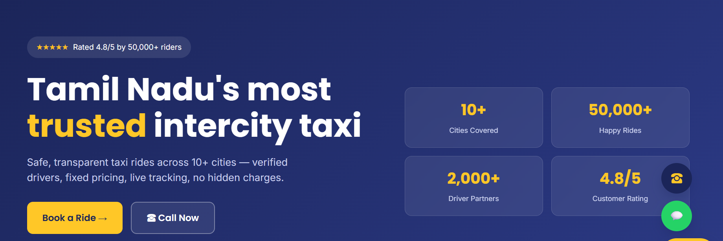
Need introduction so crisp and attention seeking - Use - Tamilnadu top-rated 24/7 kind of in the intro
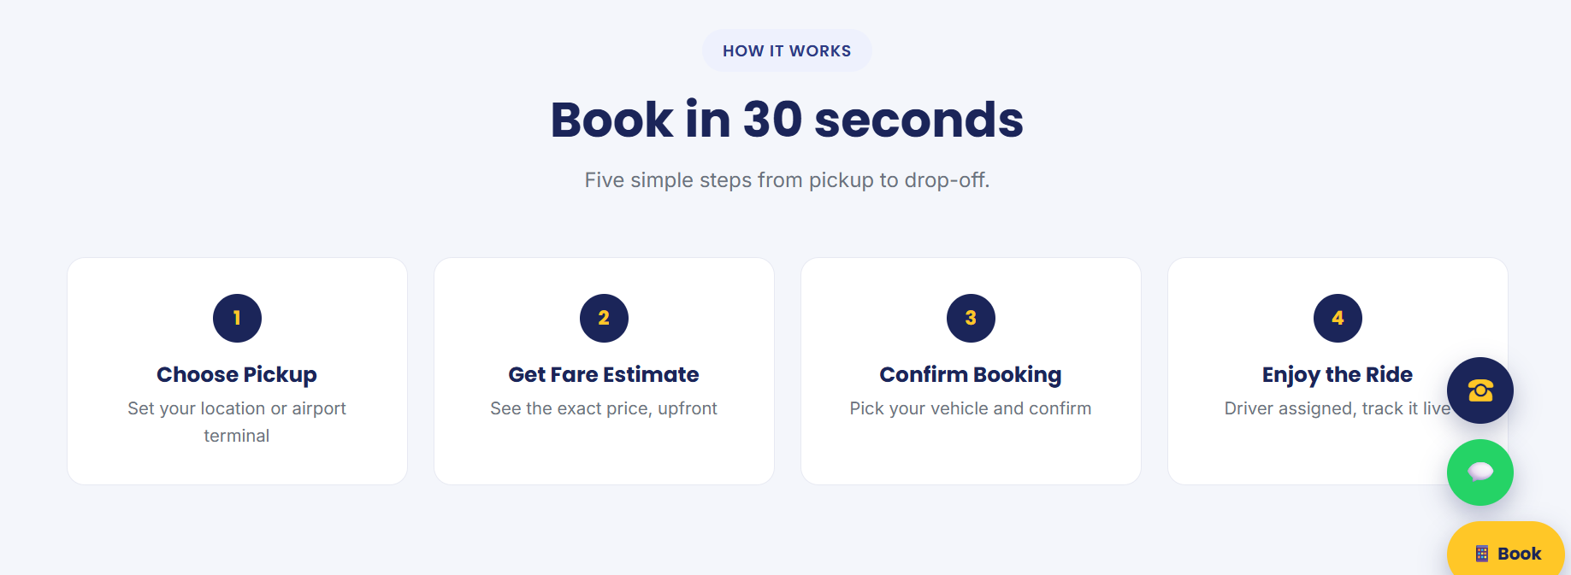
New section recommended to ensure the process of booking
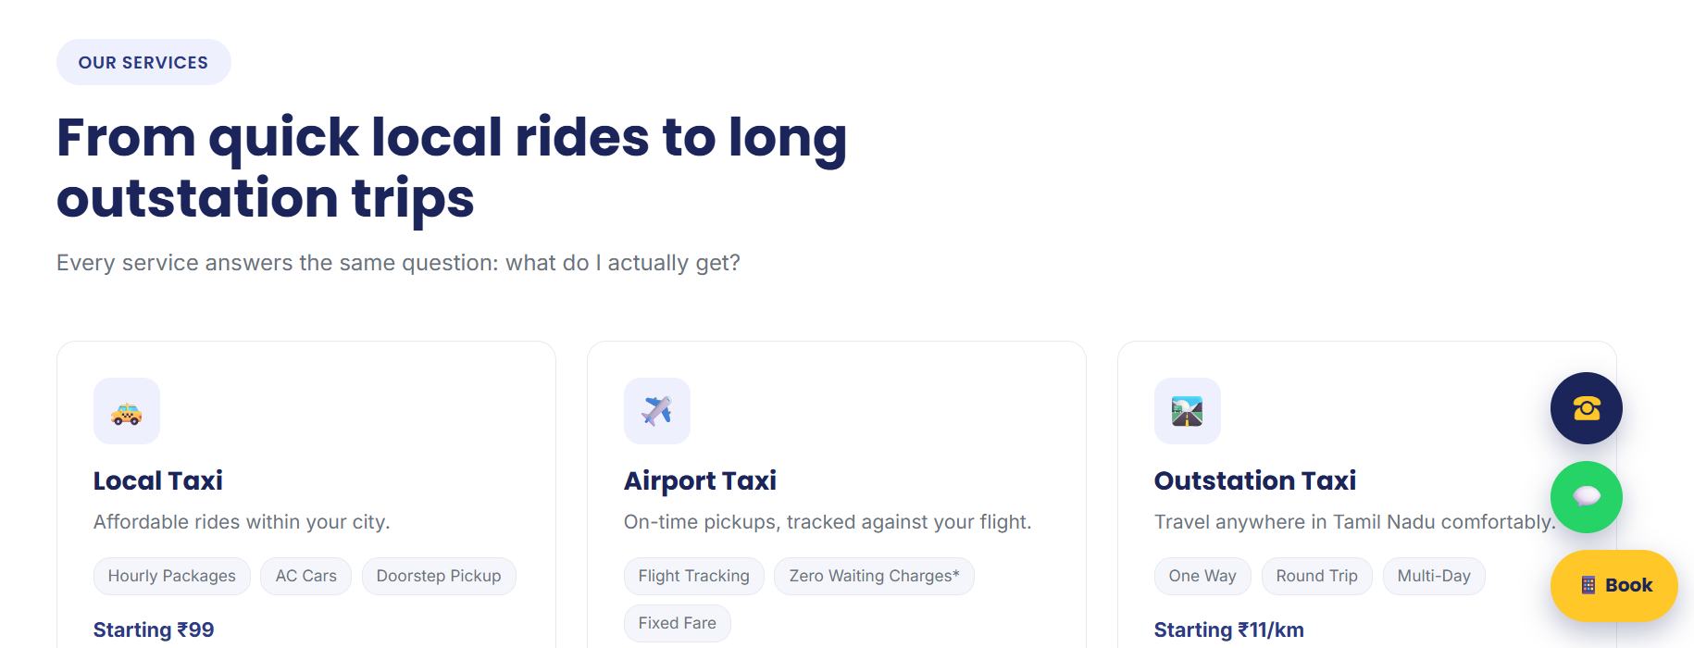
Enhance the our services section kind of - i.e “Explore our service in Root Cabs” - Mention - Outstation and Hourly Rental, One Way Taxi.
Ref - https://www.uber.com/in/en/

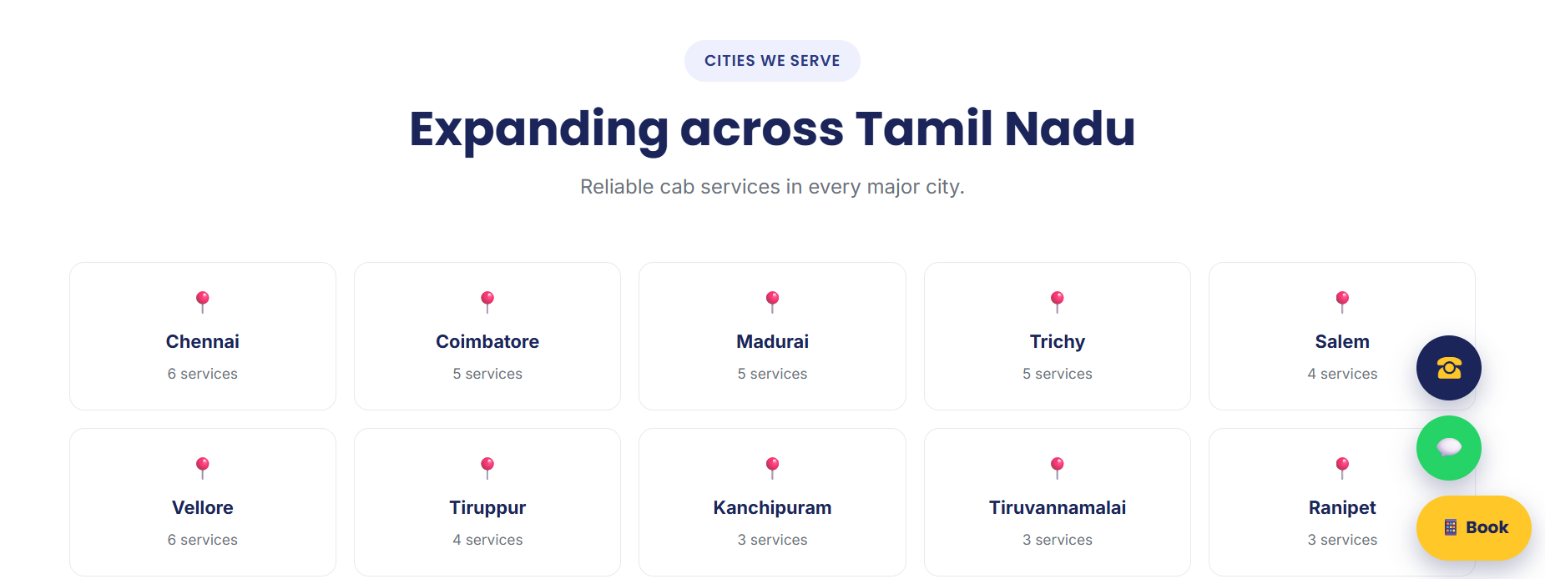

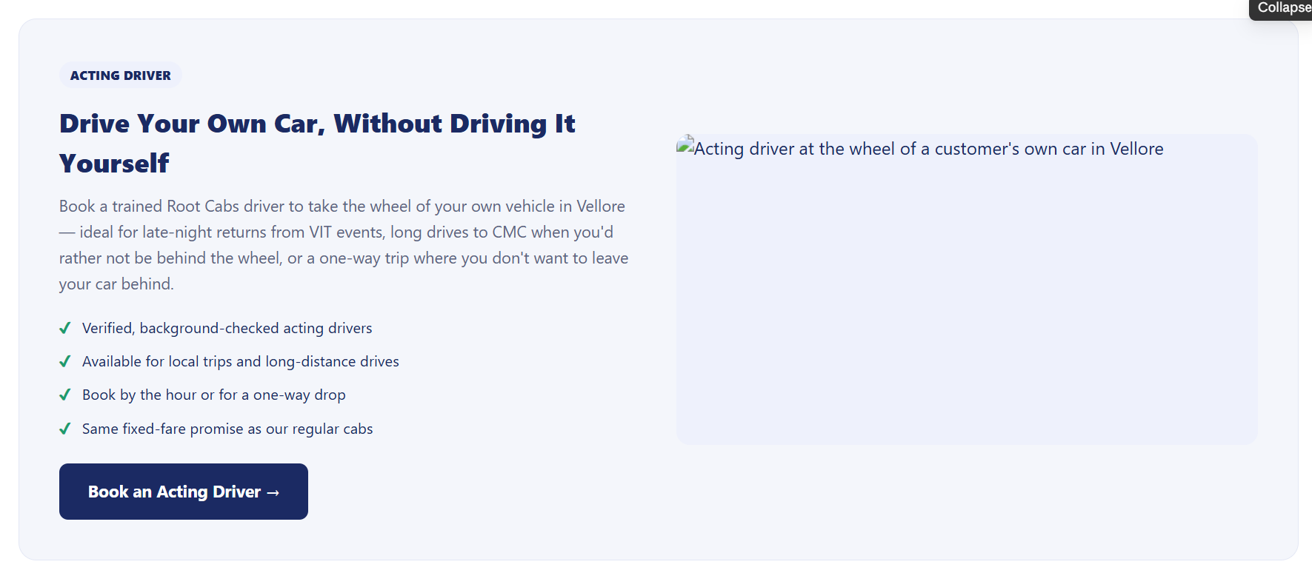

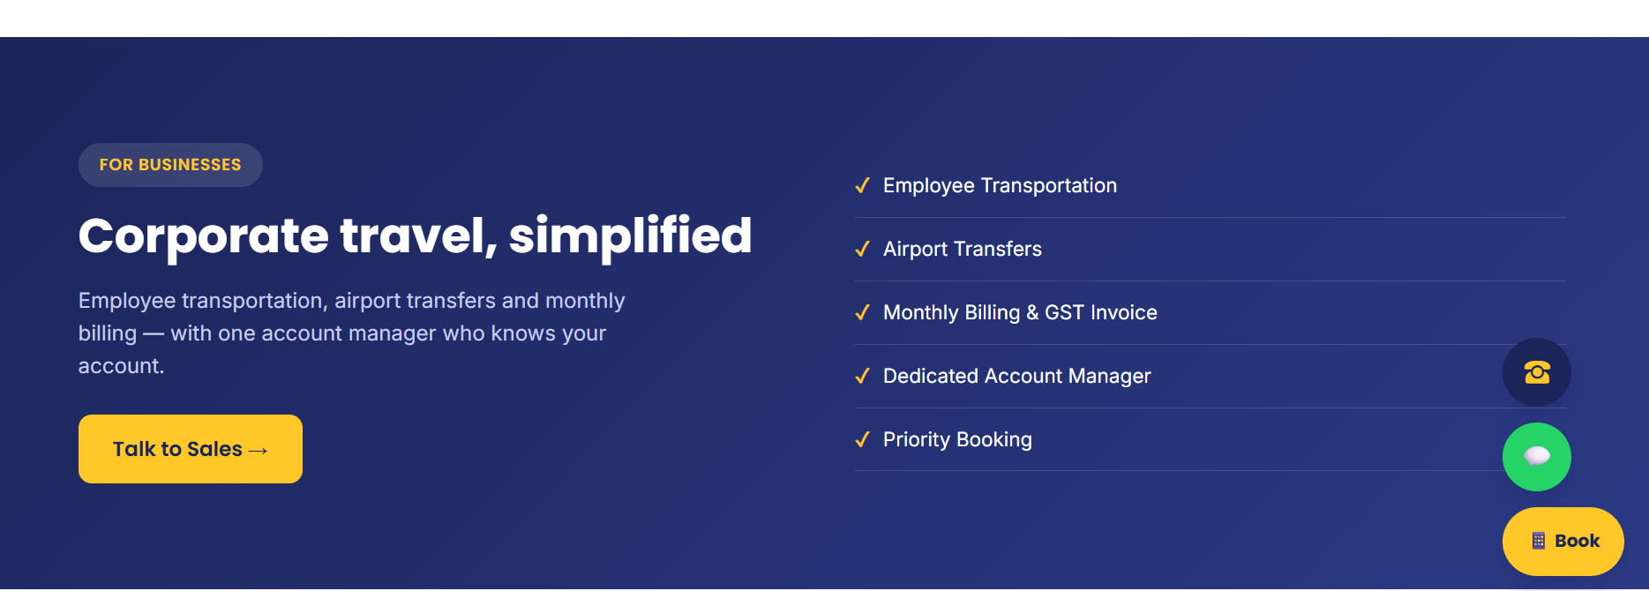

Currently we are providing - Airport Transfers - check what other things we are exactly providing.
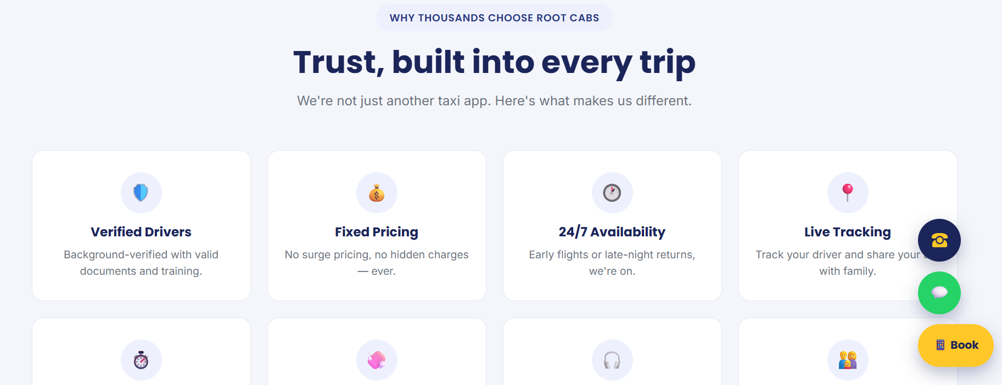

Why Choose Root Cabs - Section -


acting driver
hire a professional driver
hire a long distance driver
acting driver near me
acting driver for outstation trip
acting call driver
acting car driver
acting driver charges
acting driver charges for outstation trip
acting driver cost per day
acting driver fare
acting driver in tamil
acting driver service
acting duty driver

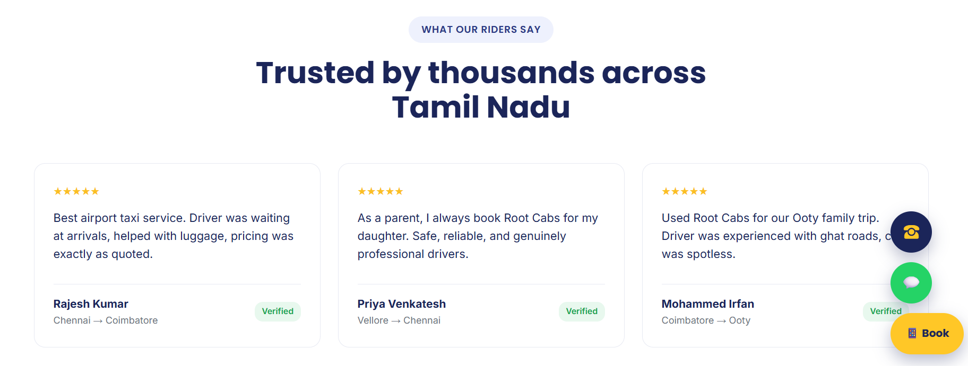

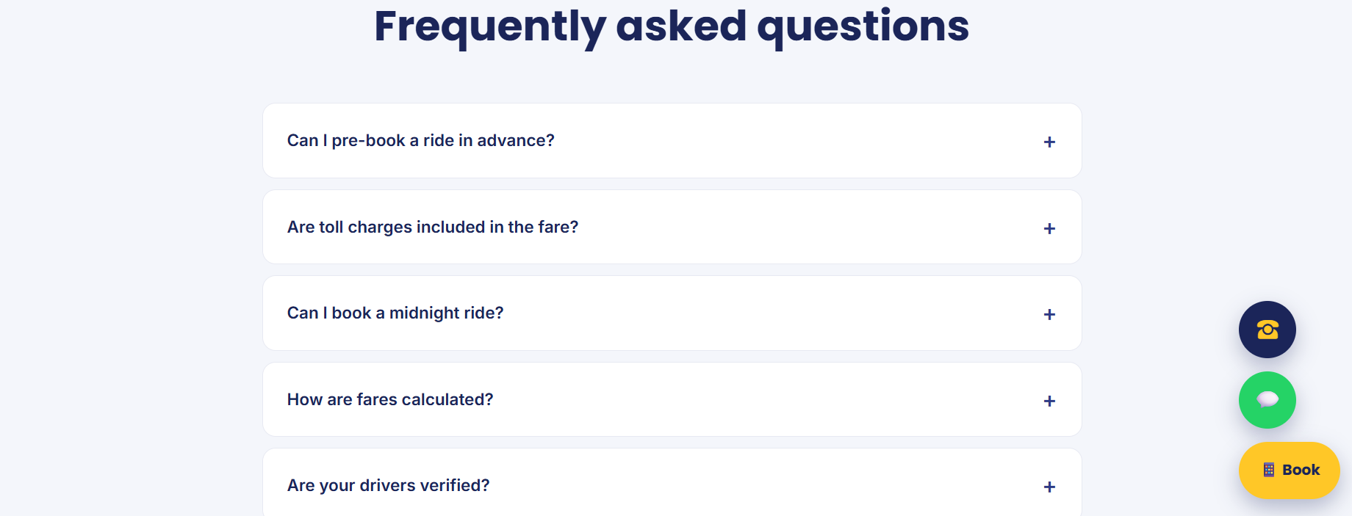
How do I call a taxi in Vellore?
How can I book a taxi service in Vellore with Root Cabs?
Does Root Cabs offer one-way taxi booking across Tamil Nadu?
Does Root Cabs provide airport transfers from Vellore and Chennai?

